**UpGrad Course 5-Capstone Project**

GitHub : <https://github.com/Sasmita1992/Devops_Capstone.git>

VPC

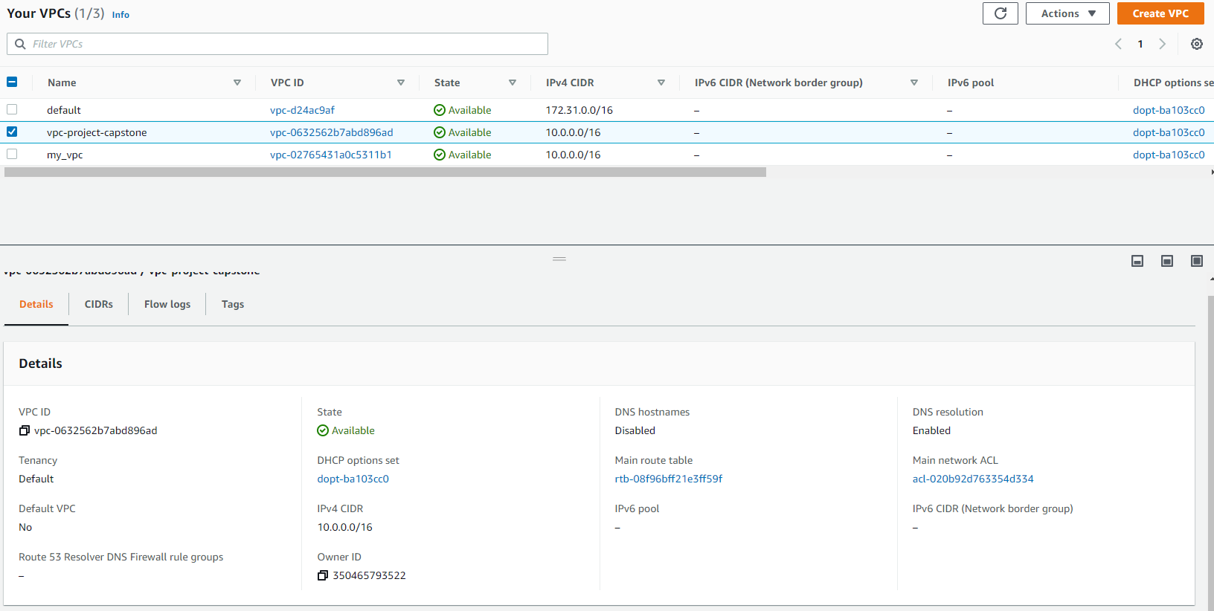

Subnets

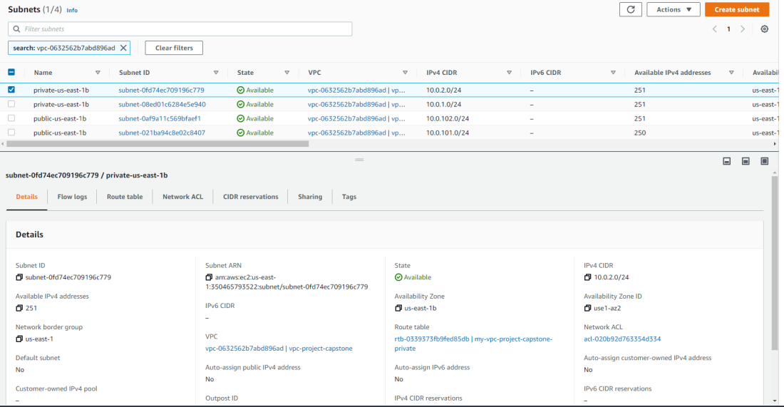

Subnets tags

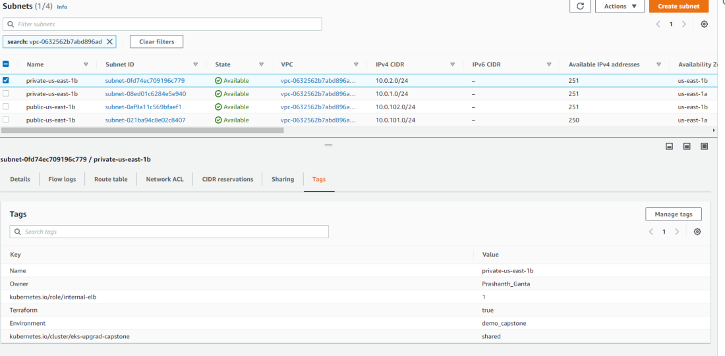

Nat Gateway

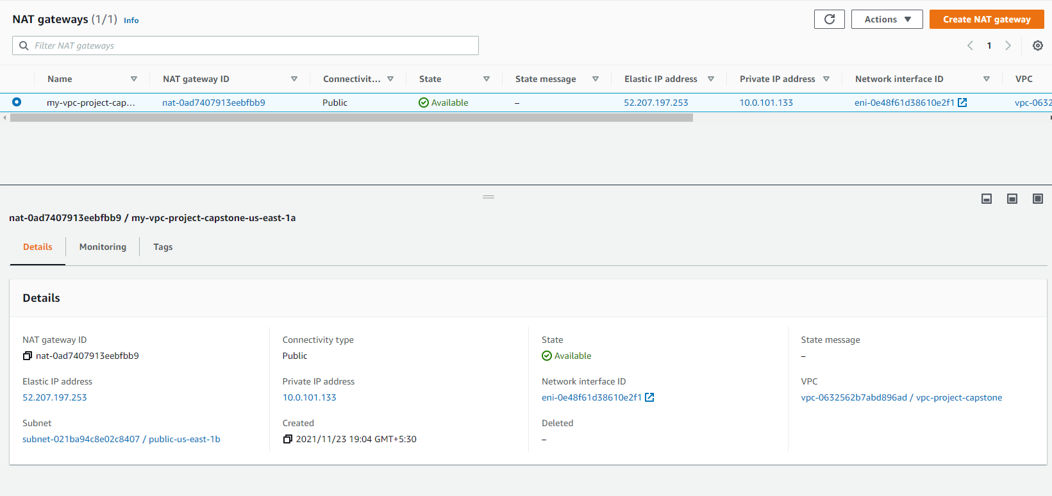

**Creating AWS EKS Cluster**

My-eks-conf.yaml

Provide the VPC and Subnets details created with VPC in cluster file according to requirements

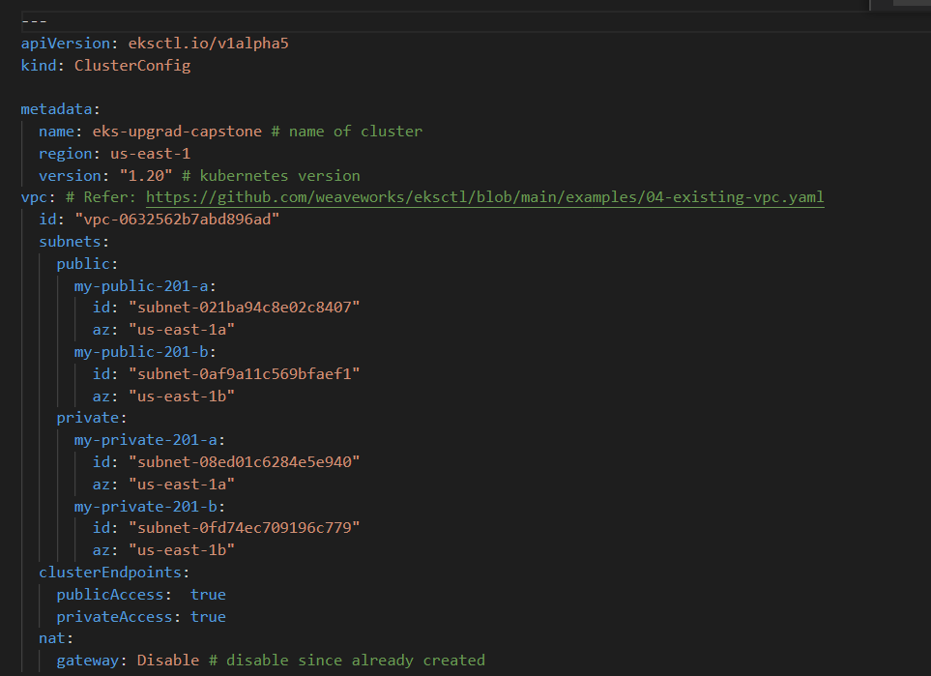

Run: eksctl create cluster -f my-eks-conf.yaml

Or run: make create_cluster (this is the direct method of running the files with make command)

EKS cluster in console

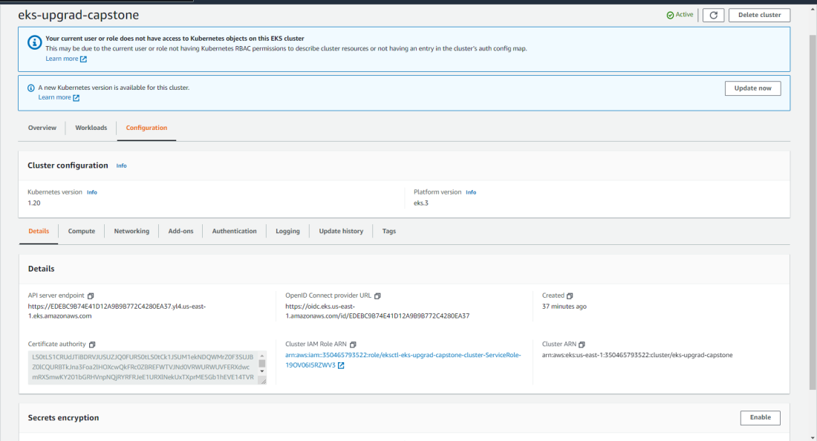

**Task 2: Deployment of sample application**

Creating Docker file and deploying into ECR

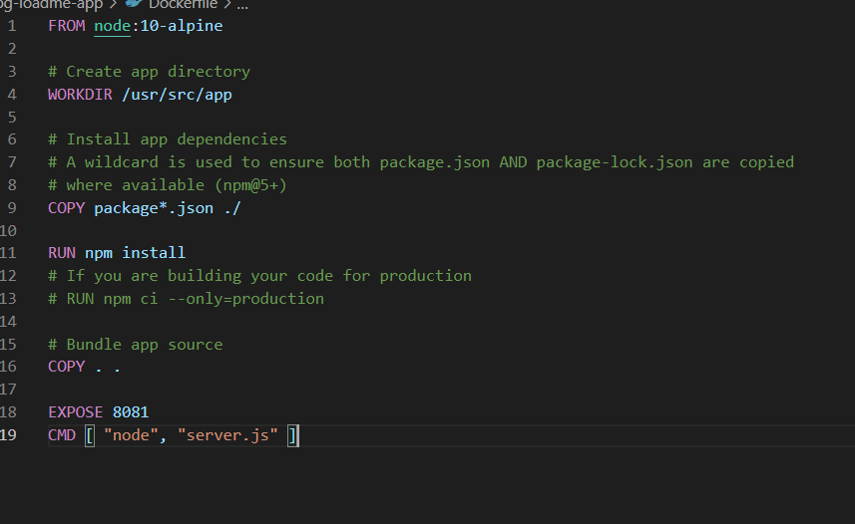

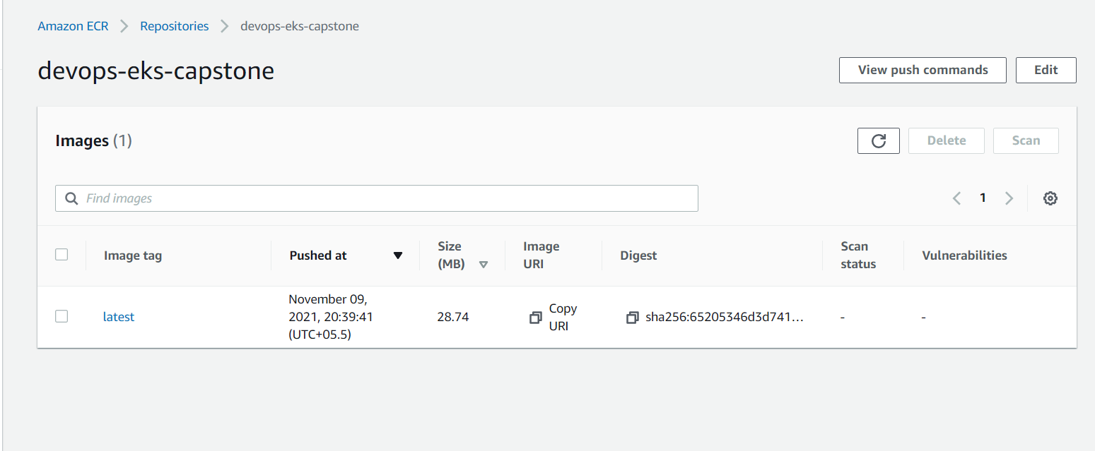

Deploying upg-loadme.yaml and upg-loadme-ingress.yaml files

eksctl apply –f "upg-loadme.yaml”

eksctl apply –f “upg-loadme-ingress.yaml”

Load-balancer end point:

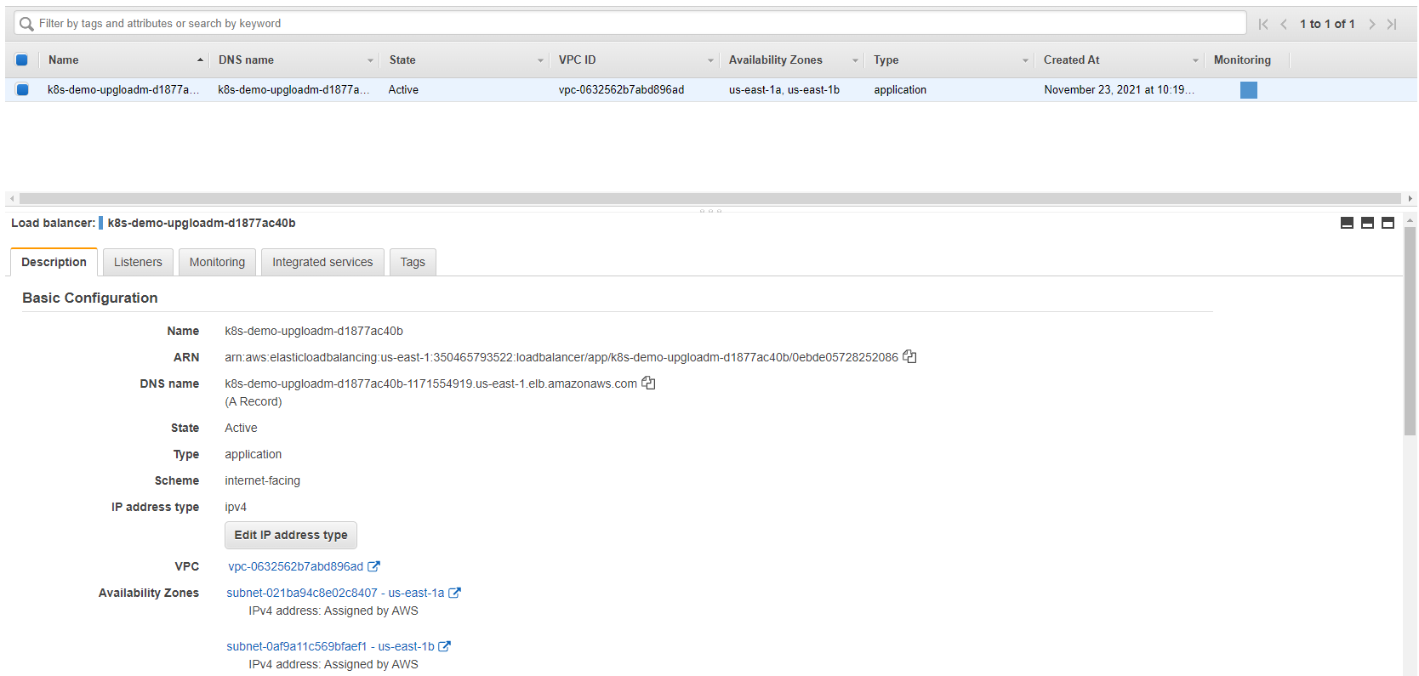

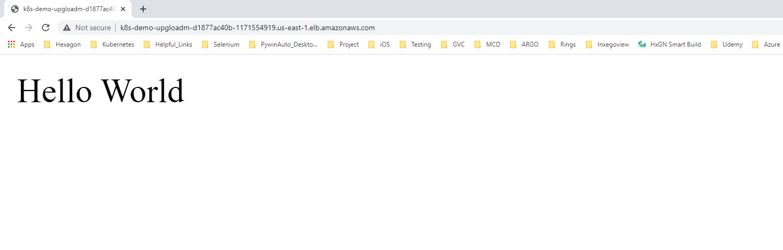

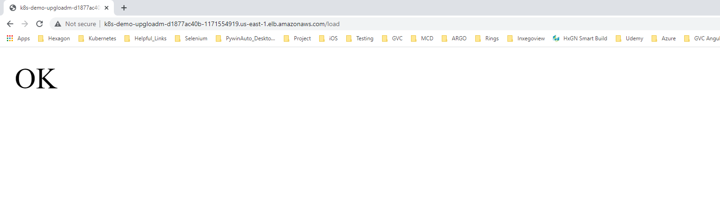Followed the below link and installed apache bench load testing

<https://www.digitalocean.com/community/tutorials/how-to-use-apachebench-to-do-load-testing-on-an-ubuntu-13-10-vps>

Grafana-Prometheus-Dashboard

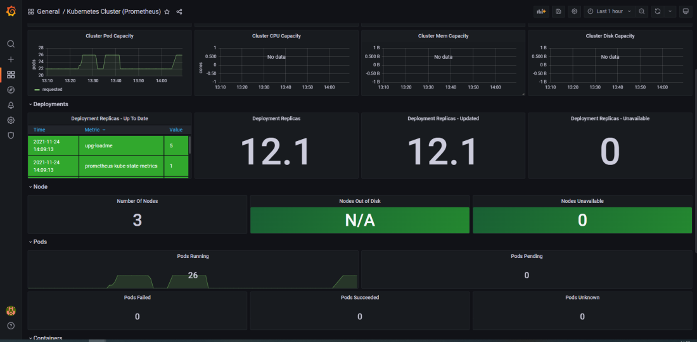

[Prometheus](http://localhost:9090/graph) Dashboard

